Anchor Point Risk
▬▬
SPECIALIST RATING SERVICES
LGD Tail Extension: the scenario selectors and what each does to the extended curve
User manual for the scenario editor | 13 October 2026 | Applies to the app version of 12 October 2026 (branch feature/three-methods-and-vintage-start)
A recovery triangle from the risk suite stops at the last month in which anything was observed, so an account valued at a late TermStep is given only the few buckets that remain and shows a loss given default close to one purely because the data ran out. The LGD Tail Extension app continues each TermStep's recovery curve beyond the observed data with a fitted tail shape, and the scenario selectors decide how that tail is fitted, how far it runs and which data it is fitted to. This manual explains every selector on the scenario editor, what it changes on the extended curve, what it leaves alone, and the figure it moves on the cohort 44 zip delivered on 2 October 2026 (97 TermSteps, opening exposure R4.02bn, discount rate 17.71% p.a.).
Section 1 shows how the extended curve is put together, because every selector acts on one of its parts. Section 2 lists the selectors in one table. Sections 3 to 7 take them group by group in the order the scenario editor shows them. Section 8 covers per-zip overrides and the assistant, section 9 the runs that fail and why, and section 10 a sensitivity table on the cohort 44 zip.

1. How the extended curve is built
The app reads lgd_recovery.csv into two triangles with TermStep down the side and bucket across: RecoveryPct(ts, b), the cash collected in bucket b as a share of the balance at TermStep ts, and ExposureBucket(ts, b), the balance behind that figure. Because the denominator is the balance at ts, the values along a row add up to the cumulative recovery. For each TermStep row the engine then takes six steps.
- Last credible bucket. The last bucket whose ExposureBucket is at least MinExposure. Observed values are kept up to it; anything beyond it is treated as too thin to trust and is replaced by the tail.
- Shape. A decay curve s(b) in the bucket number: exponential e^(−λb), power law b^(−γ) or log-normal (1/b)·exp(−(ln b − μ)²/(2σ²)). Its parameters are fitted once, on the reference TermStep row, by a log-linear least-squares regression over the buckets from FitStart to that row's last credible bucket.
- Scale. The level that makes the shape pass through the row's last W credible buckets on average: Σ observed RecoveryPct over the window ÷ Σ s(b) over the window. Every row gets its own scale; all rows share the same shape.
- Extension. Beyond the last credible bucket, RecoveryPct(ts, b) = max(floor, scale(ts) × s(b)) up to MaxBucket. All three shapes are always computed; Method chooses which one is reported as the selected result.
- LGD. LGD(ts) = 1 − Σ RecoveryPct(ts, b) × v^(b − ts + 1), where v is the monthly discount factor from the discount rate. The replica of the file's own LGD uses the observed buckets only and must tie out to the file; the extended LGD adds the tail.
- TermSteps beyond the data. Up to LastTS each TermStep uses its own row. Beyond it the base TermStep's extended cash curve is rolled forward: the balance at ts is the base balance less the cash collected between, and the remaining curve is rescaled to that balance, out to the Target TermStep.
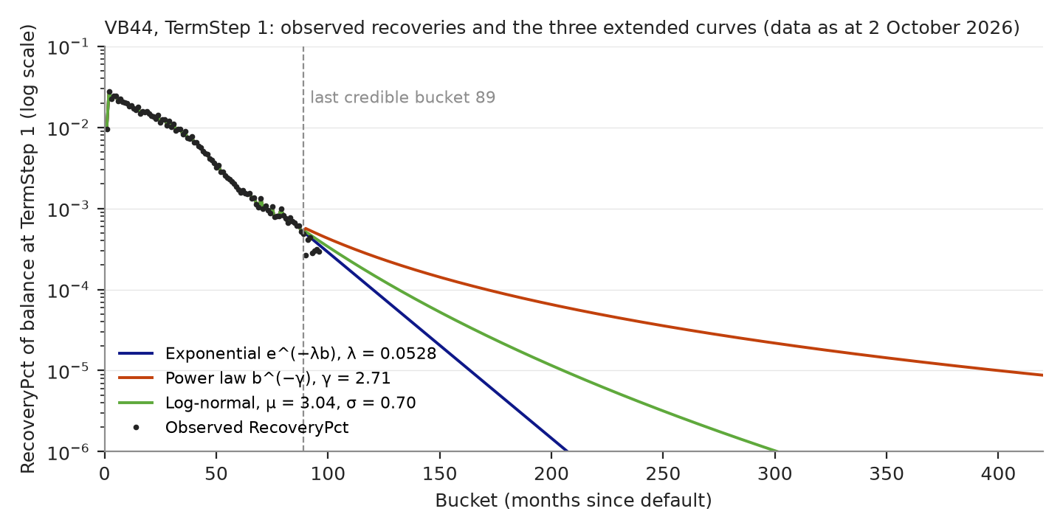
Figure 1. Cohort 44 at the default selectors, TermStep 1. Observed RecoveryPct is kept to bucket 89, the last with at least R100m of exposure; each shape continues from there, anchored on buckets 78 to 89. The exponential tail is spent by bucket 200, the power law is still paying at bucket 420.
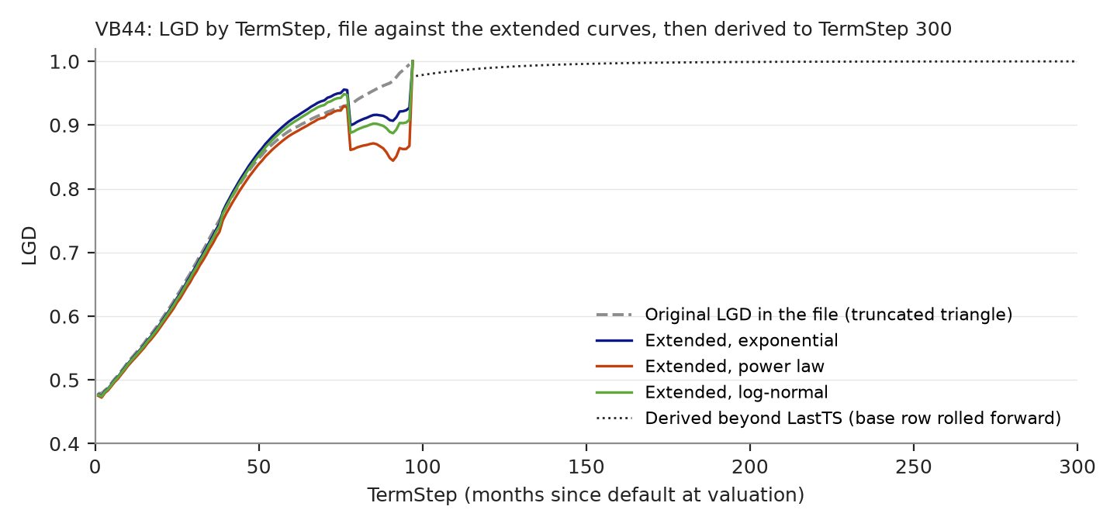
Figure 2. The same zip by TermStep. The file's LGD climbs to one as the triangle runs out; the extended curves hold it near the exponential, power-law and log-normal values. Exposure-weighted over all 97 TermSteps the file gives 0.6120 and the three shapes 0.6112, 0.6034 and 0.6090.

2. The selectors at a glance
Table 1 lists every selector in the order of the scenario editor, with its default (the value of the original framework workbooks) and the part of the extended curve it moves. The exposure-weighted selected LGD quoted in the last column is for cohort 44 at the defaults with method 3, 0.6090, and shows the direction and size of a representative change.
Selector | Default | What it moves | Cohort 44 example
Target TermStep | 300 | The length of the LGD-to-Target table. Adds or removes derived rows at the end; no observed row changes. | 360 with MaxBucket 480: 0.6090, unchanged
MaxBucket | 420 | Where the tail stops being counted. Matters for heavy tails (power law, log-normal with large σ), not for a spent exponential. | 300: 0.6090; 600: 0.6090 (tail spent); power law 300 vs 420: 0.6035 vs 0.6034
Valuation horizon | 120 | Only the LGD-within-horizon columns. | 60 months: horizon LGD 0.6210 instead of 0.6113
Short horizon | 12 | Only the short-horizon LGD columns. | none on the selected LGD
Method | 1 (new scenarios) | Which shape is the selected result, the uplift, the LGD-to-Target table and the exports. | 1: 0.6112; 2: 0.6034; 3: 0.6090
MinExposure basis | Rand | Whether the cut is a Rand amount or a share of the TermStep 1 opening exposure. | 2.5% of R4.02bn ≈ R100m: 0.6091
MinExposure | R100m | Where the observed data ends and the tail begins, on every row, and the end of the regression window. | R50m: 0.6072 (credible to bucket 96); R500m: 0.6101 (to bucket 77)
Window W | 12 | How many credible buckets set the level of the tail. Changes the level, not the shape. | 6: 0.6088; 24: 0.6099
Hazard floor | 0 | A minimum RecoveryPct on every extended bucket, to MaxBucket. | 0.0002: 0.6066; 0.001: 0.5872
Reference TermStep | 1 | The row whose tail is fitted. | 12: 0.6082 (λ 0.0512, γ 2.63)
FitStart | 24 | The first bucket in the regression. Later starts fit the tail only. | 12: 0.6094 (γ 2.03); 60: 0.6071 (λ 0.0400, 30 points)
λ, γ, μ, σ overrides | empty | Replace one fitted parameter; the others stay fitted. | λ 0.03: 0.6048; γ 2.0: 0.5986; μ 3.25 and σ 0.70: 0.6077
Base TermStep | 1 | The row rolled forward beyond LastTS. | 12: LGD at TermStep 120 0.9885 instead of 0.9895
LastTS | empty | The last TermStep that uses its own row. | 77: same averages; rows 78 to 97 become derived
Vintages | all | Which default vintages feed the triangle. Changes the data itself. | last 5 years: 0.5717 from a file LGD of 0.5969 (18 of 25 cohorts)
EventType | Lifetime | Which block of the file is used. | identical blocks in every zip so far
Discount rate | empty | The rate behind v. Breaks the tie-out to the file. | 12%: 0.5781; 25%: 0.6409
Table 1. Selectors, defaults and the part of the extended curve each one moves. Figures are the exposure-weighted selected LGD on the cohort 44 zip of 2 October 2026 with method 3 unless stated, against 0.6090 at the defaults.

3. Horizon

Target TermStep
The LGD-to-Target table runs from TermStep 1 to this value. TermSteps up to LastTS use their own extended row; those beyond are derived from the base row. Raising the Target adds derived rows at the end of the table and changes nothing on any observed row, so the exposure-weighted LGD over the observed TermSteps is unchanged. Keep MaxBucket at least Target plus the valuation horizon, or the last rows run out of buckets and the app warns that fewer than the valuation horizon remain.

MaxBucket
The last bucket to which every row is extended. Recoveries after it are not counted, so a lower MaxBucket raises LGD and a higher one lowers it by whatever the tail still pays. How much depends on the shape: on cohort 44 the exponential tail with λ = 0.0528 has a half-life of 13.1 buckets and is spent long before bucket 300, so MaxBucket 300, 420 and 600 all give 0.6090. A power law with γ below about 1.5 never stops paying, and a log-normal with a large σ pays for longer still; for those the figure keeps falling as MaxBucket rises.
A rising MaxBucket is an assumption, not evidence
On the RTC July 2026 zips the power law fitted γ between 0.12 and 0.49. Moving MaxBucket from 420 to 600 counted fifteen more years of projected collections and lowered the weighted LGD, but nothing in the data supports collections in year 40. Treat a MaxBucket beyond the longest observed history as a stress case, and say so in the report.

Valuation horizon and short horizon
Two further LGDs are reported for every TermStep: recoveries counted only within the valuation horizon (120 months by default, the window a valuation projects from any age) and within the short horizon (12 months, the 12-month ECL basis). Neither changes the lifetime figures; they let the lifetime LGD be compared with what a fixed window would see. On cohort 44 the 120-month LGD is 0.6113, within a thousandth of the lifetime 0.6090, because the exponential tail is spent inside the window; with the horizon at 60 months it is 0.6210.

4. Tail

Method
All three shapes are always computed and shown side by side; Method chooses which one becomes the selected LGD, the uplift, the LGD-to-Target table and the formula workbook's CHOOSE. Every shape is fitted to the zip's own data on the same points and scaled on the same window. Nothing is borrowed from the client except, for method 3, the functional form of its industry curves.
Method | Shape s(b) | Fitted parameters | Character of the tail | Cohort 44 at defaults
1 | e^(−λb) | λ, slope of ln R on b | Constant proportional decay; half-life ln 2 ÷ λ. The thinnest tail, the conservative view. | λ 0.0528, half-life 13.1 buckets, LGD 0.6112
2 | b^(−γ) | γ, slope of ln R on ln b | Decay slows as b grows; no half-life; the heaviest tail. Below γ ≈ 1.5 it pays for as long as MaxBucket allows. | γ 2.71, LGD 0.6034
3 | (1/b)·exp(−(ln b − μ)²/(2σ²)) | μ and σ, from ln R + ln b on ln b and (ln b)² | Rises to a peak at bucket exp(μ − σ²) then decays, heavier than the exponential and heavier still as σ grows. The form of the client's industry curves, so μ and σ compare directly with theirs. | μ 3.04, σ 0.70, peak at bucket 12.8, LGD 0.6090
Table 2. The three tail shapes. Cohort 44 figures are exposure-weighted over 97 TermSteps at the default selectors; the file gives 0.6120.
The ordering is not fixed: on cohort 44 the power law adds the most recovery, but with the last five years of vintages the exponential (0.5640) sits between the power law (0.5329) and the log-normal (0.5717). Look at the three columns together before choosing, and treat the spread between them as the model uncertainty of the extension.

MinExposure and its basis
MinExposure is the credibility cut: a bucket whose ExposureBucket is below it is treated as unobserved and replaced by the fitted tail. It is the main lever on how much of the noisy late data is trusted, and it acts twice. On every row it decides where observed data ends and the tail begins, and on the reference row it fixes the end of the regression window, so it also moves λ, γ, μ and σ. On cohort 44 the cut at R100m makes bucket 89 the last credible bucket of TermStep 1; R50m extends it to bucket 96 (λ 0.0537, γ 2.88, LGD 0.6072) and R500m pulls it back to bucket 77 (λ 0.0567, γ 2.62, LGD 0.6101). A row whose exposure never reaches the cut falls back to its last observed bucket, so nothing is lost.
The basis decides whether the cut is a Rand amount or a percentage of the TermStep 1 opening exposure. A percentage scales the cut to the size of the book, so one scenario treats cohort 44 (R4.02bn opening) and ALL (R70.6bn) alike; 2.5% of cohort 44's opening is R100m and reproduces the default, 0.6091. Use the percentage basis with a vintage window, because the subset's opening exposure is smaller than the file's.

Window W
The shape is scaled so that it passes, on average, through the last W credible buckets of each row. The window sets the level of every extended row and leaves the shape untouched, so its effect is modest where the observed tail is smooth: on cohort 44 a window of 6 gives 0.6088, 12 gives 0.6090 and 24 gives 0.6099. A wide window is steadier and less exposed to one odd month; a narrow one follows the most recent observations. A window of 1 anchors the whole tail on a single bucket and is not recommended outside a sensitivity run.

Hazard floor
A minimum RecoveryPct applied to every extended bucket out to MaxBucket. Because it is applied to hundreds of buckets, a floor that looks negligible is not: 0.0002 per bucket (0.02% of the balance each month) lowers cohort 44 from 0.6090 to 0.6066, and 0.001 lowers it to 0.5872 and pushes the LGD at TermStep 300 down to 0.43 as the floored cash accumulates. Use it only where a minimum collection rate is a defensible assumption, and never to tune a result.

5. Decay fit

Reference TermStep
The row whose observed tail is regressed to fit λ, γ, μ and σ. TermStep 1 is the longest and best-populated row and is the usual choice. A later row has fewer buckets and less exposure, so the fit is noisier: on cohort 44, TermStep 12 gives λ 0.0512 and γ 2.63 against 0.0528 and 2.71, and TermStep 36 leaves too few points for the log-normal, which then fails on method 3.

FitStart
The first bucket in the regression; the window runs from here to the reference row's last credible bucket. The default of 24 skips the early hump of fresh collections, so the regression sees the decay only. Starting earlier includes the hump and flattens the fitted decay: FitStart 12 on cohort 44 drops γ from 2.71 to 2.03 and the power-law LGD from 0.6034 to 0.5988. Starting later fits only the far tail on fewer points: FitStart 60 leaves 30 points and λ 0.0400. The app warns when fewer than three points remain, and the log-normal needs the window to contain the curve's concave part.
Short triangles and the log-normal
With the last 5 years of vintages the cohort 15, 22 and 25 zips are only 55 to 60 buckets deep. From FitStart 24 the regression sees a stretch where recoveries are still flattening, ln R + ln b is not concave in ln b, and μ and σ have no solution: method 3 fails with 'μ / σ is undefined'. FitStart 6 fits all three; FitStart 12 fits them too but gives cohort 15 a μ of 19 and σ of 5.8, a curve with no meaning. Lower FitStart until the window holds the peak, or carry μ and σ from the full-history fit as overrides.

The four overrides
Each override replaces one fitted parameter with a given value and leaves the others fitted. Only that shape's columns change. A smaller λ decays more slowly: λ 0.03 on cohort 44 gives an exponential LGD of 0.6048 against 0.6112 fitted, and λ 0.08 gives 0.6146. A smaller γ gives a heavier power tail: γ 2.0 gives 0.5986, γ 3.5 gives 0.6071. For the log-normal, μ moves the peak and the mass of recoveries later (μ 3.5 with σ refitted at 0.50 gives 0.6116) and σ widens the tail (σ 1.0 with μ refitted at 2.18 gives 0.6067). With one of μ and σ given, the other is still fitted by a single regression on the transformed points; with both given there is no fit. Setting μ 3.25 and σ 0.70, the client's own cohort 44 parameters, gives 0.6077.
Comparing the challenger's log-normal with the client's
Nutun's July 2026 curve for cohort 44 pins its location at m = 3.25. The challenger's fit on the same cohort gives μ = 3.04 and σ = 0.70 at the defaults, so the two curves peak at buckets 12.8 and about 15. Running method 3 once fitted and once with μ = 3.25 and σ = 0.70 as overrides isolates the effect of the client's location: 0.6090 against 0.6077, or 0.0013 of LGD on R4.02bn of exposure.

6. Derived LGD

Base TermStep
The row whose extended cash curve is rolled forward for every TermStep beyond LastTS. TermStep 1 is the longest row and the usual choice. The selector changes every derived row and nothing before LastTS; on cohort 44 moving it to 12 changes the LGD at TermStep 120 from 0.9895 to 0.9885 and lifts the weighted 120-month LGD from 0.6113 to 0.6455, because the roll-forward now starts from a row with less of its own history.

LastTS
The last TermStep that uses its own observed-and-extended row; later TermSteps are derived. Empty means the last observed TermStep with exposure. Lower it when the late rows rest on too little exposure to be credible: in cohort 44 the rows from TermStep 78 have under R100m of opening exposure, and a LastTS of 77 hands them to the rolled-forward base row. The exposure-weighted averages over the observed rows do not change; the LGD-to-Target table does, and the validation column shows how far each own row differs from its derived value, which is the check on whether one rolled-forward curve can stand in for the observed rows.

7. Data

Vintages
The file's lgd_recovery.csv is one triangle over every default vintage. The same zip carries runoff_triangle.csv with each vintage's exposure month by month, and the app rebuilds the triangle from it for any set of vintages: all of them, the last N years counted back from each zip's own latest vintage, or every vintage from a chosen month. On upload the rebuilt triangle is checked against the file to within rounding, and only zips that pass can be filtered; the project page shows each zip's vintage range, or 'Re-upload the zip to enable the vintage filter' for zips stored before 9 October 2026.
This selector changes the data, not the method, so it moves everything. With the last 5 years of vintages cohort 44 keeps 18 of 25 cohorts and 76% of the at-default exposure (2021-06 onwards). The triangle is only 59 buckets deep instead of 96, the opening exposure is R3.07bn instead of R4.02bn, the fit sees 35 points instead of 66 (λ 0.0494, γ 1.89, μ 3.42, σ 0.50), and the selected LGD is 0.5717 against a file LGD for that subset of 0.5969. With 3 years, 12 cohorts remain, the regression has 10 points, γ drops to 0.75 and the three shapes spread from 0.3849 to 0.5579: a short window leaves most of every row to the fitted tail. The 'Original' LGD on a filtered run is the LGD of the rebuilt subset, labelled 'LGD (vintages from …)', and ties out by construction.
Choosing a window
Last N years resolves per zip, so one scenario gives each zip its own start month: on the RTC July 2026 zips, 4 years means 2021-02 for cohorts 1 and 2 and every vintage for cohorts 3 and 5, whose histories are shorter than four years. Use 'From a month' when the window must be the same calendar date for every cohort, for example a change in collections strategy.

EventType
Which block of lgd_recovery.csv (and of runoff_triangle.csv) is used: Lifetime, LifetimeSingle or TwelveMonthSingle. In every zip delivered so far the three blocks are identical, so the selector changes nothing; it exists for files where they differ.

Discount rate
The annual rate behind the monthly factor v = (1 + r)^(−1/12), as a fraction. Empty means the rate implied by each file's own DiscountFactor, 17.71% p.a. for cohort 44. Any other value breaks the tie-out to the file's LGD, which the app reports as a warning, so use it only to test sensitivity: 12% gives 0.5781 and 25% gives 0.6409 on cohort 44, a larger effect than any shape selector.

8. Per-zip overrides and the assistant
A scenario applies to every zip in the project. Under 'Per-zip overrides' on the scenario page, or 'Edit assumptions' on a results page, any selector can be ticked and given a value for one zip; unticked selectors follow the scenario. Overrides are the right place for a cohort that needs a different FitStart, its own μ and σ, or a different vintage window, and the results page shows the zip's own values in blue. The project grid marks every cell that was run with a vintage filter.
With an API key configured, the assistant on the project and results pages turns an instruction such as 'set MaxBucket to 600 on Maximum yield' or 'give VB15 a FitStart of 6' into a proposal showing the old and new values. Nothing changes until the proposal is confirmed, and the confirmation goes through the same scenario and override endpoints with the signed-in user's role.

9. When a run fails
A failure on one zip is recorded against that zip and never stops the others. The cell on the project grid shows 'Error' with the message, and the results page repeats it in full. The messages below are the ones a selector can cause.
- 'The selected method cannot be computed because λ (or γ, or μ / σ) is undefined.' The regression could not produce a decay: fewer than three points remain between FitStart and the last credible bucket, the log-normal window is not concave in ln b, or the fitted λ or γ came out at or below zero because the window rises. Lower FitStart, widen MinExposure, use more vintages, set an override, or choose another method. The other two shapes are still reported.
- 'This zip was stored without its runoff_triangle data. Upload the zip again to enable the vintage filter.' The scenario or override asks for a vintage window and the zip was uploaded before 9 October 2026. Drop the same zip on the project again; it is updated in place and its results are marked out of date.
- 'Vintage start … is after the last vintage.' The chosen month leaves no cohorts. Choose an earlier month or fewer years.
- 'Reference TermStep (or Base TermStep) … is beyond the observed range.' The zip has fewer TermSteps than the selector asks for; use an override for that zip.
Warnings do not stop a run. The ones worth reading before relying on a figure are the tie-out warning (the discount rate differs from the file's), the file-floor warning (the risk suite floored the file's LGD, so 'Original LGD' is not 1 − CumulativeSumPV on those TermSteps), the fit warnings (fewer than three points, a rising fit, a non-concave window) and, under a vintage filter, the note that a Rand MinExposure leaves fewer than W credible buckets on the reference row.

10. Sensitivity on the cohort 44 zip
Table 3 collects the runs behind the figures in this manual: the cohort 44 zip of 2 October 2026, method 3 unless stated, Target 300 and MaxBucket 420, with one selector changed at a time. The selected column is the exposure-weighted LGD over the 97 observed TermSteps; the file's own figure is 0.6120.
Change from the defaults | Selected | Exponential | Power law | Log-normal | λ | γ | μ / σ
defaults (method 3) | 0.6090 | 0.6112 | 0.6034 | 0.6090 | 0.0528 | 2.706 | 3.043 / 0.703
method 1 | 0.6112 | 0.6112 | 0.6034 | 0.6090 | 0.0528 | 2.706 | 3.043 / 0.703
method 2 | 0.6034 | 0.6112 | 0.6034 | 0.6090 | 0.0528 | 2.706 | 3.043 / 0.703
max_bucket 300 | 0.6090 | 0.6112 | 0.6035 | 0.6090 | 0.0528 | 2.706 | 3.043 / 0.703
max_bucket 600 | 0.6090 | 0.6112 | 0.6034 | 0.6090 | 0.0528 | 2.706 | 3.043 / 0.703
target 360, max 480 | 0.6090 | 0.6112 | 0.6034 | 0.6090 | 0.0528 | 2.706 | 3.043 / 0.703
min_exposure R50m | 0.6072 | 0.6086 | 0.6021 | 0.6072 | 0.0537 | 2.877 | 3.179 / 0.633
min_exposure R500m | 0.6101 | 0.6109 | 0.5969 | 0.6101 | 0.0567 | 2.624 | 3.244 / 0.586
min_exposure 2.5% of opening | 0.6091 | 0.6112 | 0.6035 | 0.6091 | 0.0528 | 2.706 | 3.043 / 0.703
window 6 | 0.6088 | 0.6108 | 0.6037 | 0.6088 | 0.0528 | 2.706 | 3.043 / 0.703
window 24 | 0.6099 | 0.6121 | 0.6039 | 0.6099 | 0.0528 | 2.706 | 3.043 / 0.703
window 1 | 0.6091 | 0.6109 | 0.6046 | 0.6091 | 0.0528 | 2.706 | 3.043 / 0.703
floor 0.0002 | 0.6066 | 0.6080 | 0.6024 | 0.6066 | 0.0528 | 2.706 | 3.043 / 0.703
floor 0.001 | 0.5872 | 0.5875 | 0.5860 | 0.5872 | 0.0528 | 2.706 | 3.043 / 0.703
fit_start 12 | 0.6094 | 0.6107 | 0.5988 | 0.6094 | 0.0503 | 2.026 | 3.166 / 0.658
fit_start 36 | fails | – | – | – | – | – | –
fit_start 60 | 0.6071 | 0.6083 | 0.6047 | 0.6071 | 0.0400 | 2.949 | 3.362 / 0.692
ref_ts 12 | 0.6082 | 0.6109 | 0.6030 | 0.6082 | 0.0512 | 2.630 | 2.950 / 0.757
ref_ts 36 | fails | – | – | – | – | – | –
lambda 0.03 (method 1) | 0.6048 | 0.6048 | 0.6034 | 0.6090 | 0.0300 | 2.706 | 3.043 / 0.703
lambda 0.08 (method 1) | 0.6146 | 0.6146 | 0.6034 | 0.6090 | 0.0800 | 2.706 | 3.043 / 0.703
gamma 2.0 (method 2) | 0.5986 | 0.6112 | 0.5986 | 0.6090 | 0.0528 | 2.000 | 3.043 / 0.703
gamma 3.5 (method 2) | 0.6071 | 0.6112 | 0.6071 | 0.6090 | 0.0528 | 3.500 | 3.043 / 0.703
mu 3.5 | 0.6116 | 0.6112 | 0.6034 | 0.6116 | 0.0528 | 2.706 | 3.500 / 0.499
sigma 1.0 | 0.6067 | 0.6112 | 0.6034 | 0.6067 | 0.0528 | 2.706 | 2.180 / 1.000
mu 3.25 sigma 0.70 | 0.6077 | 0.6112 | 0.6034 | 0.6077 | 0.0528 | 2.706 | 3.250 / 0.700
base_ts 12 | 0.6090 | 0.6112 | 0.6034 | 0.6090 | 0.0528 | 2.706 | 3.043 / 0.703
last_ts 77 | 0.6090 | 0.6112 | 0.6034 | 0.6090 | 0.0528 | 2.706 | 3.043 / 0.703
last_ts 0 | 0.6090 | 0.6112 | 0.6034 | 0.6090 | 0.0528 | 2.706 | 3.043 / 0.703
rate 0.12 | 0.5781 | 0.5813 | 0.5696 | 0.5781 | 0.0528 | 2.706 | 3.043 / 0.703
rate 0.25 | 0.6409 | 0.6424 | 0.6374 | 0.6409 | 0.0528 | 2.706 | 3.043 / 0.703
horizon2 60 | 0.6090 | 0.6112 | 0.6034 | 0.6090 | 0.0528 | 2.706 | 3.043 / 0.703
vintages last 5 years | 0.5717 | 0.5640 | 0.5329 | 0.5717 | 0.0494 | 1.894 | 3.417 / 0.501
vintages last 3 years | 0.5579 | 0.4873 | 0.3849 | 0.5579 | 0.0268 | 0.753 | 3.407 / 0.524
vintages from 2020-01 | 0.6273 | 0.6276 | 0.6205 | 0.6273 | 0.0597 | 2.754 | 3.286 / 0.542
Table 3. Exposure-weighted LGD on cohort 44 with one selector changed at a time. 'fails' means the selected method was undefined for that setting. Vintage rows compare with the rebuilt subset's own LGD, not the file's 0.6120.
Three selectors dominate on this zip: the discount rate, which is not a modelling choice; the vintage window, which changes the data; and the hazard floor, which adds cash by assumption. The shape selectors move the figure by a few thousandths between them, and that spread is the honest measure of what the extension adds to the truncated file.

Henry Edwards
Director, Head of Credit
Anchor Point Risk

